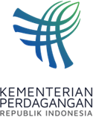
PRESS RELEASE
Public Relations Bureau
Bldg. I Fl. 2, Jl. M.I. Ridwan Rais No. 5, Jakarta 10110 Phone: 021-3860371/Fax: 021-3508711
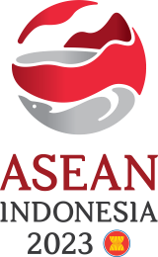
www.kemendag.go.id
Chairing the AEM-ABAC Consultation Meeting, Trade Minister Zulkifli Hasan: Strengthen ASEAN Cooperation with the Private Sector
Semarang, 19 August 2023 — Indonesian Minister of Trade Zulkifli Hasan encouraged ASEAN to become stronger in order to be able to respond to various challenges in the future, including strengthening ASEAN's unity and centrality. Increasing ASEAN cooperation with the private sector is an important factor in strengthening ASEAN.

This was conveyed by the Minister of Trade, Zulkifli Hasan, in the consultation meeting of the ASEAN Economic Ministers (AEM) with the ASEAN Business Advisory Council (ASEAN-BAC), or AEM-ABAC Consultation today, Saturday (19/8) in Semarang, Central Java.

"Of course, the strengthening of ASEAN can be achieved because of the involvement of and cooperation with the private sector which is the main actor of trade in ASEAN. I hope today's meeting can be a good opportunity to further strengthen cooperation and increase collaboration with the ASEAN Business Advisory Council," said Trade Minister Zulkifli Hasan opening the consultation meeting.

The meeting was attended by ASEAN Economic Ministers, ASEAN Secretary General Kao Kim Hourn, and Deputy Secretary General for the ASEAN Economic Community Satvinder Singh. At the meeting, ASEAN-BAC Chair, Arsjad Rasjid, and representatives of ASEAN-BAC from all ASEAN countries were also present.

In 2023, ASEAN's gross domestic product growth is projected to reach 4.6 percent and will increase to 4.8 percent next year. Trade Minister Zulkifli Hasan is also optimistic that the end of the Covid-19 pandemic will bring fresh air to economic growth and revive trade enthusiasm in ASEAN.

Trade Minister Zulkifli Hasan revealed that there were four targets in this AEM-ABAC Consultation Meeting. The first target is to discuss the five priority issues of ASEAN-BAC. The five issues are digital transformation, sustainable development, food security, health security, and trade and investment facilitation.

"The second target is that ASEAN Ministers and ASEAN-BAC agree to increase intra-ASEAN trade and investment, enhance the electric vehicle ecosystem, mobilize carbon markets, and implement regional payment systems through quick response (QR) codes," said Trade Minister Zukifli Hasan.

Meanwhile, the third target is collaboration with business actors and the fourth target is internal consultation with ASEAN-BAC in each ASEAN country.

The ASEAN-BAC Chair, Arsjad Rasjid said, in general, the ASEAN Economic Ministers accepted the ASEAN-BAC recommendations brought to the meeting. “The ASEAN Economic Ministers accepted the existence of a joint committee between the government and the business sector. This is where the public-private partnership occurs, because it is very important. Nowadays, nothing succeeds alone. We can call this ASEAN Incorporated (ASEAN Inc.)," said Arsjad.

Semarang is hosting the series of the 55th AEM Meeting and Related Meetings on 17-22 August 2023. Starting with preparatory meetings or Prep-SEOM for two days on Thursday and Friday, 17- 18 August 2023, the series will continue with a series of ASEAN Economic Ministerial Meetings for four days from Saturday to Tuesday, 19-22 August 2023.
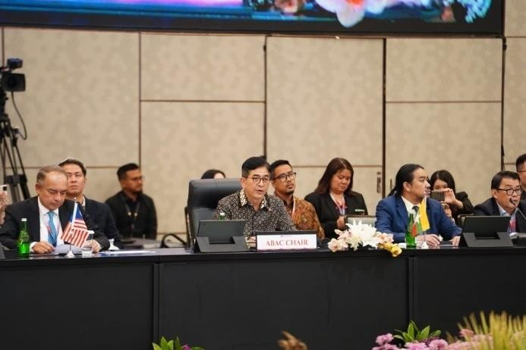
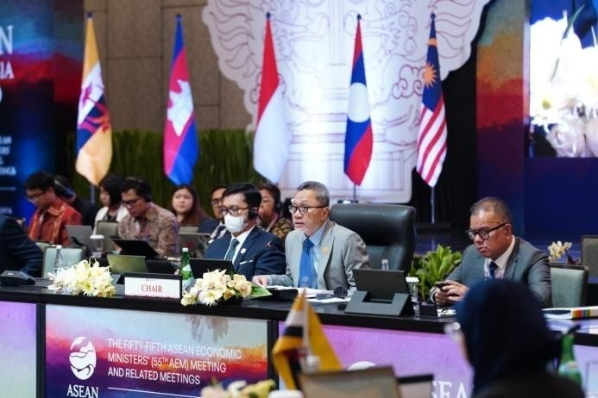
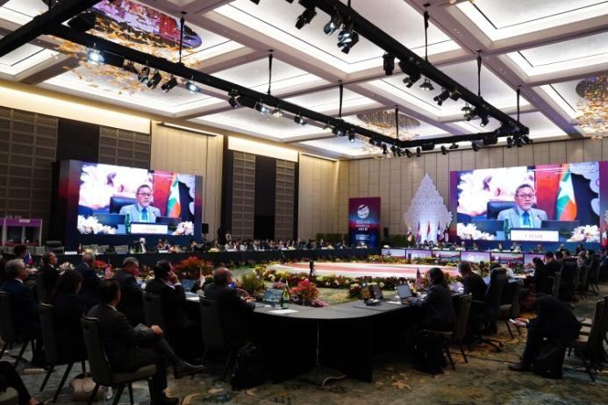
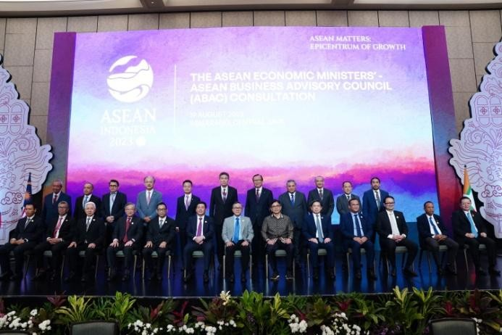

--end--

For further information please contact:  Ani Mulyati  Head of Public Relations Bureau Ministryof Trade  Email: pusathumas@kemendag.go.id | Dina Kurniasari  Director of ASEAN Negotiations  Directorate General of International Trade Negotiations Ministry of Trade  Email: asean@kemendag.go.id

